**EXP NO 2: CREATE A SIMPLE CLOUD SOFTWARE APPLICATION FOR FLIGHT RESERVATION SYSTEM USING ANY CLOUD SERVICE PROVIDER TO DEMONSTRATE SAAS.**

**DATE:**

**AIM:**

To create a simple cloud software application for flight reservation system using

any cloud service provider to demonstrate saas.

**PROCEDURE:**

step1: Go to zoho.com.

step 2: Log into the zoho.com.

step 3: Select one application step.

step4: Enter application name as flight reservation system.

step 5: Created new application flight reservation system.

step 6: Select one form

step 7: The software has been created.

IMPLEMENTATION:

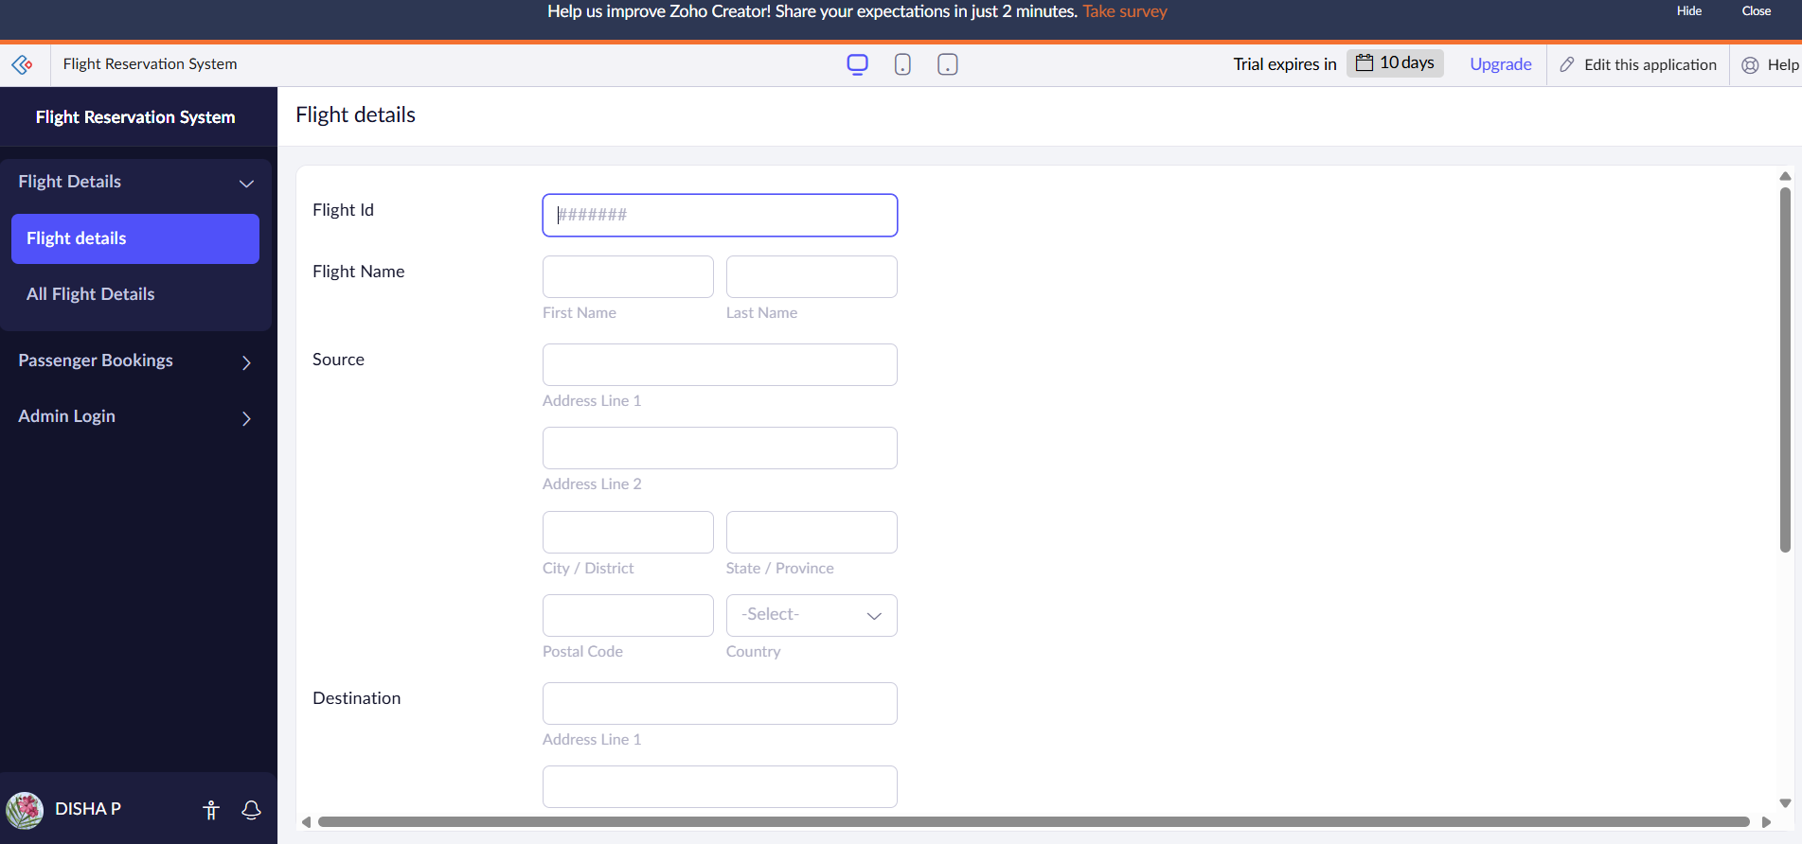

Here details Flight form has been created.

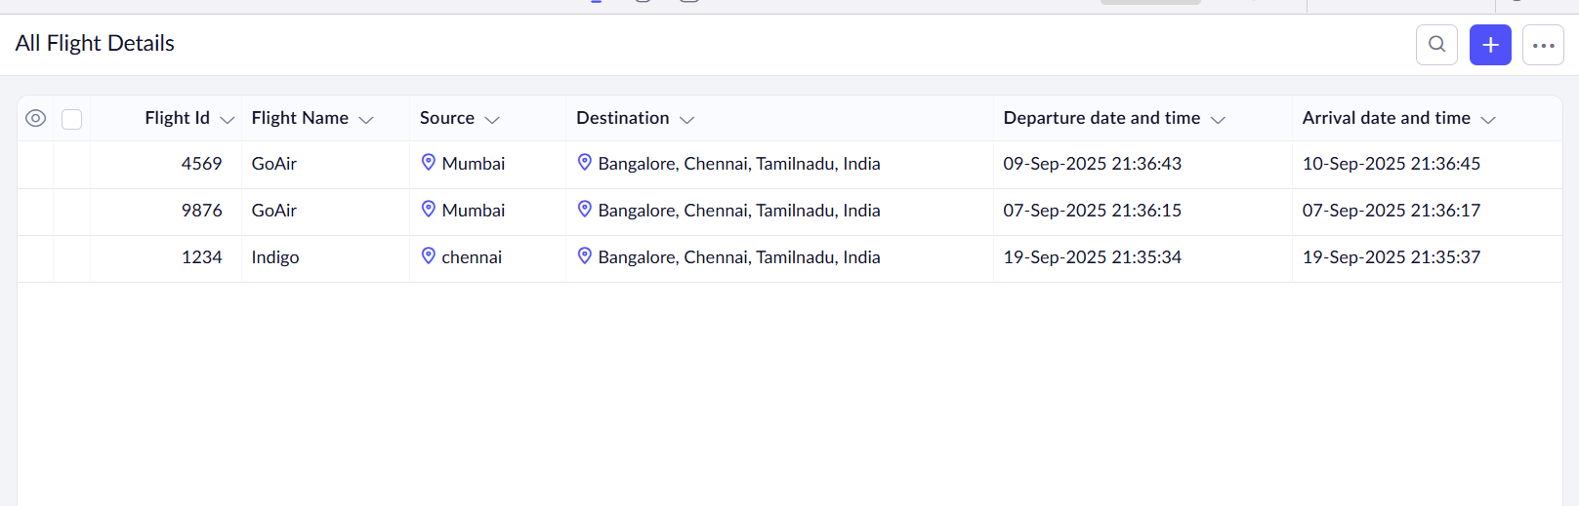

Details have been filled

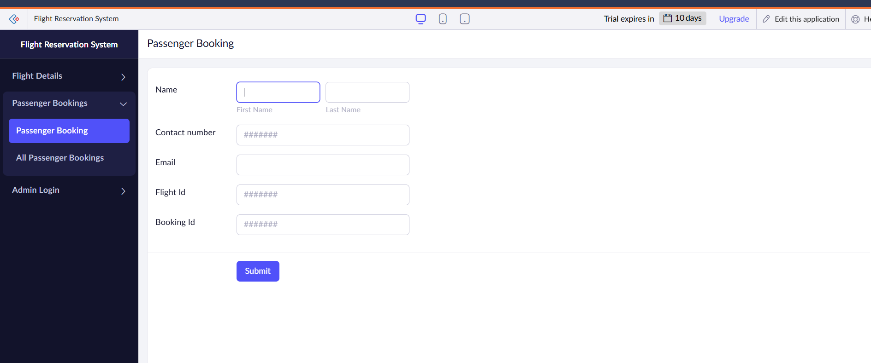

The passenger booking details form has been created.

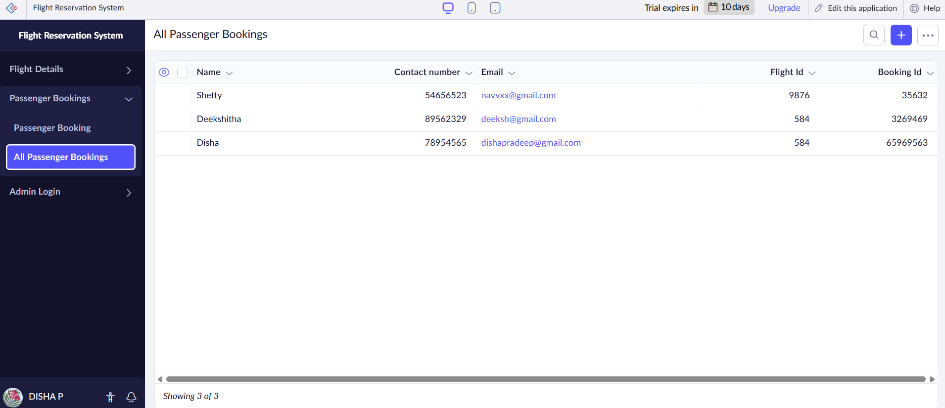

Here the details have been filled.

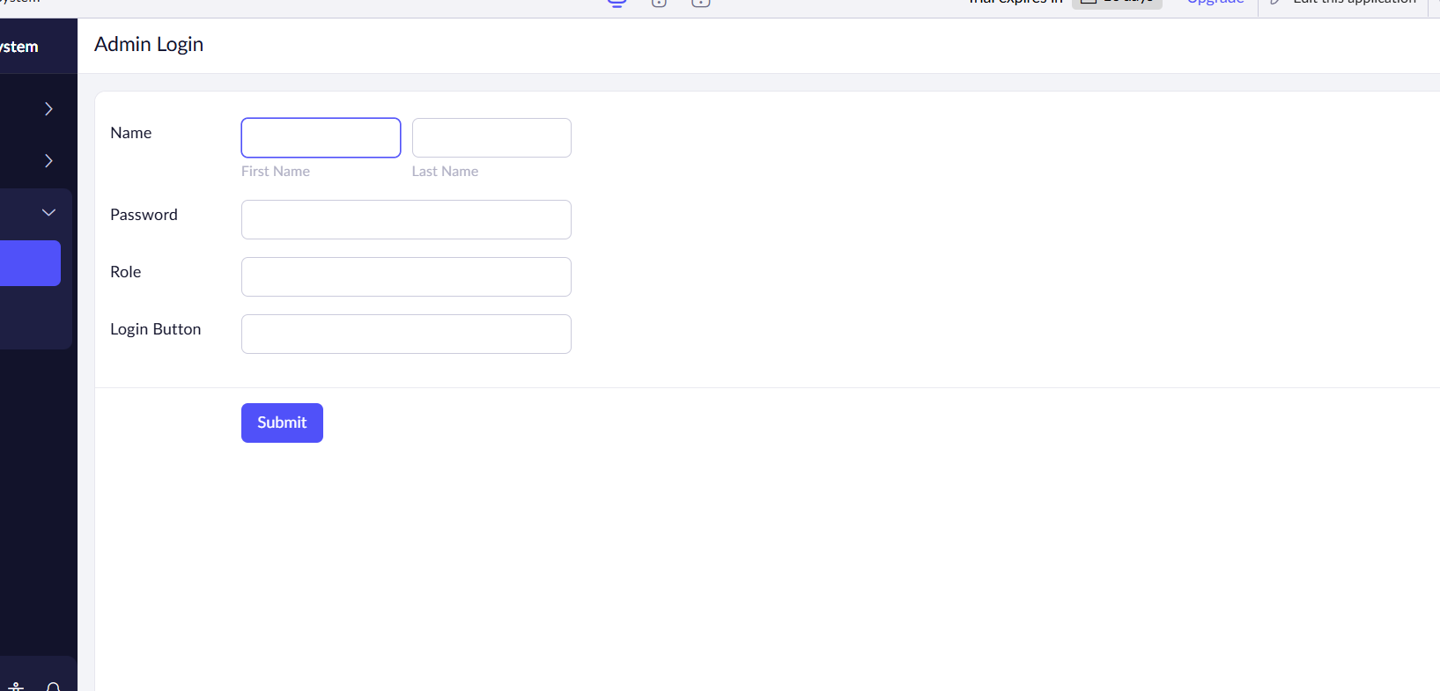

Admin report has been done.

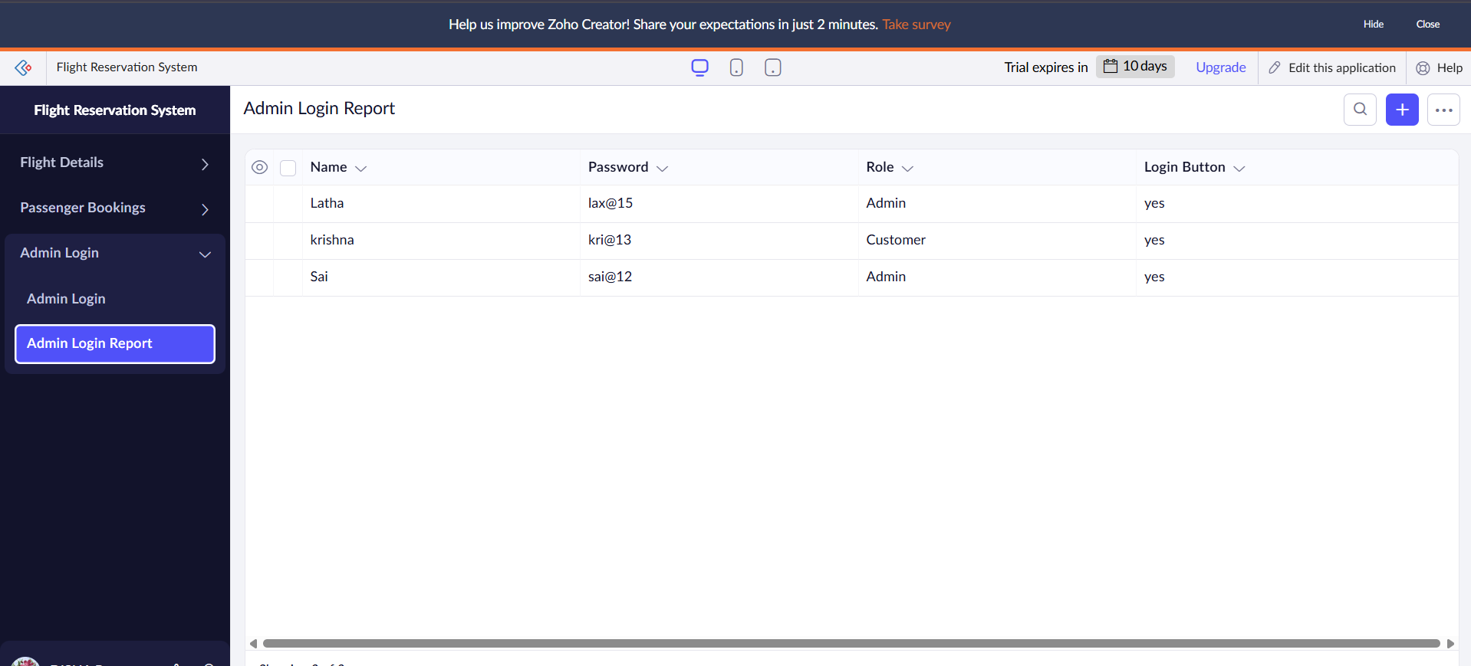

Admin form has been filled

Result :

Thus the flight booking reservation form has been done.